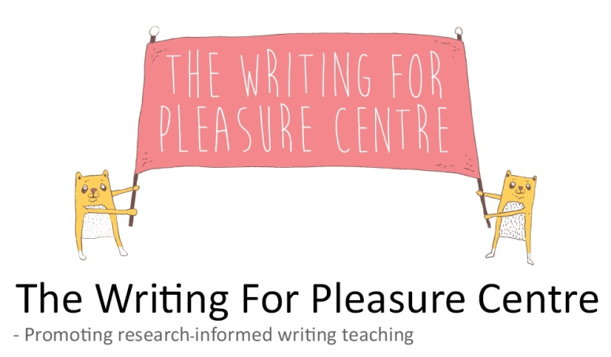

Effective Writing Practices: Teacher Audit

Full Name & Year Group: _______________________________________

How confident are you in your knowledge of the following? | 4  Very | 3 | 2 | 1  Not | Comments
Teaching writing
Adapting your teaching for children with SEND or EAL
Challenging your greater depth writers
Assessing writing
Creating an environment where children can write with enjoyment, satisfaction and pleasure
Teaching children the writing processes and associated strategies
The typical linguistic, literary and grammatical features employed in the most common writing genres.
Teaching about the function of grammar and punctuation
How confident are you with these approaches to teaching writing? | 4  Very | 3 | 2 | 1  Not
Planning authentic and purposeful writing projects
Setting writing goals
Teaching writing across the curriculum
Using children’s reading to inform their writing
Sharing your own writing with your class
Pupil-conferencing and giving verbal feedback
Giving children personal writing time
Is there anything you would like particular help with when we come to visit?

Create Purposeful & Authentic Class Writing Projects  For Example: | Achievements | Areas You Are Interested In Developing
- Develop class writing projects that are undertaken over an extended period of time.
- Plan class writing projects which match the purposes for writing undertaken by writers out in the world.
- Ensure children believe the writing project to be authentic, has genuine purpose, and is meaningful to their development as a writer.
- Classes undertake genre study in preparation for writing their own pieces.
- Once complete, ensure the children’s writing is seen by real and varied audiences.
- Afford children some ownership over the ideas they’ll use to complete the writing project.
- Encourage children to harness their own funds of knowledge in their writing.
- Children know why they are undertaking the writing project and are motivated by it.

Teach The Writing Processes  For Example: | Achievements | Areas You Are Interested In Developing
- Explicitly model, teach, provide resources and use displays to aid children’s understanding and competency of all of the following writing processes:
  - idea generation
  - planning (prewriting)
  - drafting
  - revising
  - editing (proofreading)
  - publishing or performing
- With younger children, teach the writing process in a linear step-by-step way.
- Teach children a variety of strategies they could use to complete the different stages of the writing process.
- Build on what children already know and have practised to increase their levels of independence and personal mastery of the writing processes.
- In the older years, ensure children know that the writing processes are flexible, creative, recursive and not linear.
- Once experienced enough, allow children to personalise the way they plan, draft, revise, edit and publish their writing and let them use strategies they feel help them produce their best writing.

Set Writing Goals  For Example: | Achievements | Areas You Are Interested In Developing
The Distant Writing Goal
- Ensure children know what the final goal for the class project is and spend time getting their views and discussing the project with them.

Process Goals (Writing Deadlines)
- With younger children, set a class writing deadline for the children to try and achieve within a lesson or over a number of lessons.
- Be flexible when setting writing deadlines.
- As children become more experienced, set longer deadlines and allow children to manage their own deadlines.

Product Goals (Success Criteria)
- Examine exemplar texts with your class and generate product goals for the writing project.
- Share examples of your own writing.
- Ensure children are actively involved in setting the product goals for the class writing project.
- Ensure the class’ product goals are well known and/or on display.
- Over the course of a project, ensure children know how they can achieve the product goals and what resources or strategies will help them.

Be Reassuringly Consistent  For Example: | Achievements | Areas You Are Interested In Developing
- Follow a daily, efficient and easy routine of:
  - mini-lesson
  - writing time
  - class-sharing
- Writing lessons last between one hour and one hour and twenty minutes.
- Set manageable time allocations for different parts of the lesson to ensure children receive writing instruction and undertake the act of writing daily.
  - Mini-Lesson (10-15 minutes)
  - Writing Time (30-45 minutes)
  - Class Sharing (15-20 minutes)
- Ensure routines, access to resources and behavioural expectations are clear and consistent.

Teach Mini-Lessons  For Example: | Achievements | Areas You Are Interested In Developing
- Daily mini-lessons include:
  - Writing study lessons where children learn strategies and techniques for negotiating the writing process and are then invited to use them during that day’s writing time.
  - Functional grammar lessons where children learn about certain literary, linguistic or grammatical features and are then invited to use them during that day’s writing time.

- Follow a routine of:
  - Explain
  - Model
  - Invite

Create resources that will aid children in being more independent.

Balance Composition & Transcription  For Example: | Achievements | Areas You Are Interested In Developing
- Have high expectations for transcriptional accuracy, spelling and handwriting.
- Encourage children to concentrate on the composition of their piece before placing their attention on transcriptional accuracy and the use of conventions later into a project.
- Explicitly teach techniques for revising and proof-reading.
- After drafting, allow children specific and ample time to revise and then separate time to proof-read their pieces.
- Creating revision and editing checklists to help children know what to do and how to do it whilst revising and proof-reading.
- Encourage children to use a variety of strategies for spelling whilst drafting including invented spellings.
- Provide children with resources and time in which to check and correct invented and other ‘unsure’ spellings before publishing.
- Teach handwriting and keyboard skills through the publishing of writing projects.

Build A Community Of Writers  For Example: | Achievements | Areas You Are Interested In Developing
- Build safe, caring, positive, passionate and social environments in which to write.
- Ensure children in your class identify themselves as writers rather than as children who are simply schooled in producing writing products for the teacher’s evaluation.
- Encourage children to bring their own ‘funds of knowledge’ into the classroom.
- Encourage children to write at home and for them to share it with the class community.
- Use communities and the world outside the classroom to support writing undertaken inside school.
- Help children feel that they are and can be successful when writing.
- Help give children ownership over their writing ideas and their writing process.
- Help children feel that they know what they have to do and how to do it.
- Help children feel that they are coming into class every day to take part in important writing and to engage in important learning.

Treat Every Child A Writer  For Example: | Achievements | Areas You Are Interested In Developing
- Articulate that every child can write authentically, that all children belong in the community, all children can achieve and that all members have something worthwhile to say.
- Regularly find out what is stopping children to feel confident and independent when writing, and plan and teach mini-lessons in response.
- Don’t confine less-experienced writers to decontextualized writing exercises or tasks but rather support these writers through group teaching or by allowing them to work collaboratively with two more experienced peers.
- Have high expectation for both class and personal writing projects.
- Have high expectations for student attainment during their lesson(s).
- Have a good understanding of the learning needs of all children. When they don’t know how to do something, respond by teaching it as a mini-lesson.
- Support children’s efforts and writing through your manner, comments and actions.

Read, Share, Think & Talk About Writing  For Example: | Achievements | Areas You Are Interested In Developing
- See writing as a social activity.
- See talk as vital to the process of writing.
- Ritually, give children ample time for reading and discussing their writing with each other at different stages of the writing process.
- Understand the power of children sharing and talking about their published writing with real audiences.
- Model and take part in children talking about and reflecting on writing, including: what they’ve done, what they are thinking of doing, what they’ve learnt and/or what their writing goals are.
- Undertake responsive teaching by asking your class what they feel they need instruction in most.
- Talk is about the content of children’s writing, genre conventions, and the writing processes.
- Encourage children to regularly re-read and share their compositions with their peers.
- End writing sessions with author’s chair where children are given an opportunity to talk and share their developing pieces with the class and seek their comments and advice.

Be A Writer-Teacher  For Example: | Achievements | Areas You Are Interested In Developing
- Investigate, model, discuss and write alongside your children during writing sessions.
- Write for pleasure in your own life and bring these pieces of writing into the classroom as a teaching resource.
- Share your own writing into the class library.
- Produce exemplars for your pupils to discuss and extract product goals from.
- Discuss the writing strategies you use or used when you are/were writing.
- Share your writely knowledge with your class.
- Talk to the children in your class writer-to-writer.
- Become a member of a writer-teacher group.

Pupil Conferencing: Meeting Children Where They Are  For Example: | Achievements | Areas You Are Interested In Developing
- Make children feel emotionally secure and able to talk about their writing.
- Conduct pupil-conferencing in a systematic way and appreciate this is the most effective way of giving feedback.
- Listen carefully to children’s writing issues before giving direct and clear instruction on how to deal with it – ensuring the child feels confident in enacting the advice before moving on.
- Provide conferences which have an ‘enabling’ feeling about them – with independence clearly a high priority.
- Use group conferencing by trying to bring ‘overhearers’ into any conversation that may be fruitful to the children involved.
- Discuss writing through a mastery rather than a performance perspective.
- Focus on the writing goals achieved in a child’s writing and also set new ones.
- Provide feedback and writerly advice to children during class sharing time.
- Use after-the-event written feedback only when you feel it will make a difference.

Personal Writing Projects: Writing Everyday  For Example: | Achievements | Areas You Are Interested In Developing
- Timetable regular and significant time for children to develop personal writing projects.
- Provide children with resources and strategies for generating writing ideas.
- Provide opportunities for children to write in collaboration with their peers on personal writing projects.
- Allow children to pursue their personal projects if they’ve finished their writing goal for that lesson.
- Have high expectations and interest in both class and personal writing projects.
- Design your classroom to ensure that children can pursue their personal projects largely independently.
- Promote the use of writing journals at school and at home and create links between the two.
- Children are encouraged to write personal writing projects in any pockets of time available in the school day.
- Make children feel that they want to write in their free time.

Literacy For Pleasure: Reading & Writing Connecting  For Example: | Achievements | Areas You Are Interested In Developing
- Teach reading through a reading for pleasure pedagogy.
- Provide ample time for children to read.
- Build a community of readers and writers concurrently.
- Have a print-rich classroom which includes books about writing.
- Read aloud a variety of texts regularly with pleasure and enthusiasm.
- Promote children to read like writers and write like readers – looking for links between the books they read and:
  - their own lives.
  - other books or media (films, TV, internet, video games).
  - things happening in the world.
- Encourage children to collect words, phrases, characters, settings and ideas from their reading and collect them in their writing journals.
- Regularly talk about reading in general conversation, by discussing themes and analyze a writer’s craft.
- Encourage, model and give children opportunity to use aspects of their own reading in their writing projects.
- Allow free reading time to lead into some free writing time.
- Allow children to write in personal response to the books they are reading.

